Homework 4

Ashmitha Murali
Prof. Alex Yang
Digital Design and HDL EE461
5th November 2025

Q1.
Result:
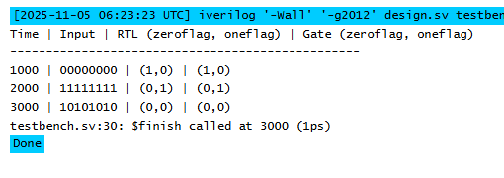
Code:
RTL level module:
`timescale 1ns/1ps
module detect_all_rtl (
input wire [7:0] din,
output wire zeroflag,
output wire oneflag
);

assign zeroflag = ~|din;
assign oneflag = &din;
endmodule

Gate Level module:
module detect_all_gates (
input wire [7:0] din,
output wire zeroflag,
output wire oneflag
);

wire or01, or23, or45, or67;
wire or0123, or4567, or_all;

or (or01, din[0], din[1]);
or (or23, din[2], din[3]);
or (or45, din[4], din[5]);
or (or67, din[6], din[7]);
or (or0123, or01, or23);
or (or4567, or45, or67);
or (or_all, or0123, or4567);
not (zeroflag, or_all);

wire and01, and23, and45, and67;
wire and0123, and4567;

and (and01, din[0], din[1]);
and (and23, din[2], din[3]);
and (and45, din[4], din[5]);
and (and67, din[6], din[7]);
and (and0123, and01, and23);
and (and4567, and45, and67);
and (oneflag, and0123, and4567);
endmodule

Testbench:
module tb_detect_all_0_1_simple;
reg [7:0] din;
wire zeroflag_rtl, oneflag_rtl;
wire zeroflag_gate, oneflag_gate;

detect_all_rtl dut_rtl (.din(din), .zeroflag(zeroflag_rtl), .oneflag(oneflag_rtl));
detect_all_gates dut_gate (.din(din), .zeroflag(zeroflag_gate), .oneflag(oneflag_gate));

initial begin
$display("Time | Input | RTL (zeroflag, oneflag) | Gate (zeroflag, oneflag)");
$display("-------------------------------------------------");

din = 8'b00000000;
#1;
$display("%4t | %b | (%0d,%0d) | (%0d,%0d)",
$time, din, zeroflag_rtl, oneflag_rtl, zeroflag_gate, oneflag_gate);

din = 8'b11111111;
#1;
$display("%4t | %b | (%0d,%0d) | (%0d,%0d)",
$time, din, zeroflag_rtl, oneflag_rtl, zeroflag_gate, oneflag_gate);

din = 8'b10101010;
#1;
$display("%4t | %b | (%0d,%0d) | (%0d,%0d)",
$time, din, zeroflag_rtl, oneflag_rtl, zeroflag_gate, oneflag_gate);

$finish;
end
endmodule

Q2.
Result:
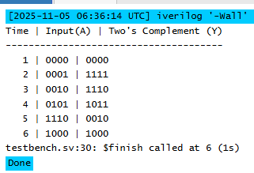
Code:
module twos_complement_4bit (
input wire [3:0] A,
output wire [3:0] Y
);
//Bitwise inversion
wire [3:0] inv;
not (inv[0], A[0]);
not (inv[1], A[1]);
not (inv[2], A[2]);
not (inv[3], A[3]);

//full adders to add 1
wire c0, c1, c2;
xor (Y[0], inv[0], 1'b1);
and (c0, inv[0], 1'b1);

xor (Y[1], inv[1], c0);
and (c1, inv[1], c0);

xor (Y[2], inv[2], c1);
and (c2, inv[2], c1);

xor (Y[3], inv[3], c2);
endmodule

Testbench:
module tb_twos_complement_4bit;
reg [3:0] A;
wire [3:0] Y;

twos_complement_4bit dut (.A(A), .Y(Y));

initial begin
$display("Time | Input(A) | Two's Complement (Y)");
$display("--------------------------------------");

A = 4'b0000; #1; // 0 → 0
$display("%4t | %b | %b", $time, A, Y);

A = 4'b0001; #1; // +1 → -1 (1111)
$display("%4t | %b | %b", $time, A, Y);

A = 4'b0010; #1; // +2 → -2 (1110)
$display("%4t | %b | %b", $time, A, Y);

A = 4'b0101; #1; // +5 → -5 (1011)
$display("%4t | %b | %b", $time, A, Y);

A = 4'b1110; #1; // -2 → +2 (0010)
$display("%4t | %b | %b", $time, A, Y);

A = 4'b1000; #1; // -8 → +8
$display("%4t | %b | %b", $time, A, Y);

$finish;
end
endmodule

Q3.

Result:
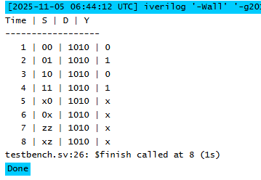
When we assign x or z to select lines the output will be assigned to x. This is because when a select line bits is neither 1 or 0 then the output will be unknown.

Code:
module mux4to1 (
input wire [3:0] D,
input wire [1:0] S,
output wire Y
);

assign Y = (S == 2'b00) ? D[0] :
(S == 2'b01) ? D[1] :
(S == 2'b10) ? D[2] :
(S == 2'b11) ? D[3] : 1'bx;
endmodule

Testbench:
module tb_mux4to1;
reg [3:0] D;
reg [1:0] S;
wire Y;

mux4to1 uut (.D(D), .S(S), .Y(Y));

initial begin
$display("Time | S | D | Y");
$display("------------------");
D = 4'b1010;

S = 2'b00; #1; $display("%4t | %b | %b | %b", $time, S, D, Y);
S = 2'b01; #1; $display("%4t | %b | %b | %b", $time, S, D, Y);
S = 2'b10; #1; $display("%4t | %b | %b | %b", $time, S, D, Y);
S = 2'b11; #1; $display("%4t | %b | %b | %b", $time, S, D, Y);

S = 2'bx0; #1; $display("%4t | %b | %b | %b", $time, S, D, Y);
S = 2'b0x; #1; $display("%4t | %b | %b | %b", $time, S, D, Y);
S = 2'bzz; #1; $display("%4t | %b | %b | %b", $time, S, D, Y);
S = 2'bxz; #1; $display("%4t | %b | %b | %b", $time, S, D, Y);

$finish;
end
endmodule

Q4.
- always @(a, b, c) begin
d = a + b;
e = d + c;
end
- b. always @(a, b, c) begin
e = d + c;
d = a + b;
end
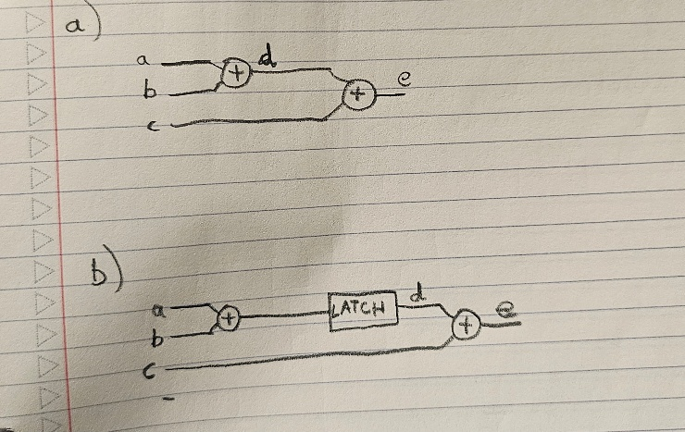

Since we are using blocking assignments the order of the assignments matter.
In the first question a+b is assigned to d and the updated value of d is added with c to get e.
But in the second question d and c values are added first and then d is updated with a+b. Hence we need to use old value of d to get e. Hence we implement a latch that stores previous value of d to be added to c.

Q5.
Since we have case statement where all the input combinations for 3 bit select lines are not in the case, a latch will be formed at the output. To prevent a latch from forming, we can tie down the output to 0 when one of the cases is not specified.

module mux(
input wire a,b,c,d,e,
input wire [2:0] sel,
output reg out
);
always @* begin
// Option A: give a default first (no latch even if case misses)
out = 1'b0; // choose a defined default for 101/110/111
case (sel)
3'b000: out = a;
3'b001: out = b;
3'b010: out = c;
3'b011: out = d;
3'b100: out = e;
// no need for default here since we preassigned out
endcase
end
endmodule

Schematic:
